ATA Quick Guide to Store-Forward Teledermatology for Referring Providers
Karen McKoy, Scott Norton, Charles Lappan
1. Work Flow
HIPAA secure transmission

Referral site
Consent, history,
image acquisition,
medical record keeping

Consulting dermatologist receives consult and returns a report

2. Equipment
Camera – digital ( avoid PDA and cellphone)
ideal 1024 X 768 dpi ( about .8 megapixel); minimum 800 X 600 dpi
macro mode capability ideal ( “flower” image)
3. Taking the Image
Background – use a solid , neutral color perpendicular to camera angle

Lighting – diffuse, indirect light is best. Avoid shadows. Indoors – fluorescent day-light
or full spectrum bulbs are best ( avoid incandescent). Outdoors – use well-lit, but evenly
shaded area if sunny.

Flash – helps to eliminate shadows. Test to see if needed. May cause white-out if too close.
Compression – use JPEG medium or low setting (no more than 20:1).

Focus – adjust camera and patient to have camera angle perpendicular to are imaged. Use
auto-focus with area of interest in center of frame; if not possible, focus 1st on area of
interest, depress shutter button half-way to focus and then move camera to center the
image before fully depressing shutter button.

Views – take to show location and arrangement of lesions. Take several views – far (entire
body or obvious region), medium (area involved central but include an anatomical
landmark such as the navel or hand), and close-up ( if you have a macro capacity–the
“flower”image, this can be taken under 18 inches from the skin – otherwise you may use the
optical zoom if present to focus for a close-up). use staright on and obliques views for
close-ups.

Tips – use a chaperone if needed; avoid distracting jewelry and clothing; in hairy areas tape
or press back to show underlying skin changes. For face shots, eyes should be open.
4. Before and After Sending the Consult
Review images for focus and adequate views before the patient leaves.
Send only helpful and good images to the consultant.
Do not alter images in any way after taken.
Label images, transmitted text and consultant response to become part of a secure,
and retrievable medical record.

TELEDERMATOLOGY IMAGING SETS

Show entire anatomic unit (e.g. trunk) if a lesion or rash is within this unit.

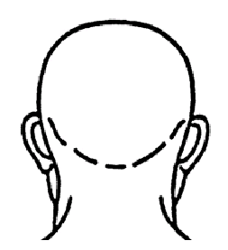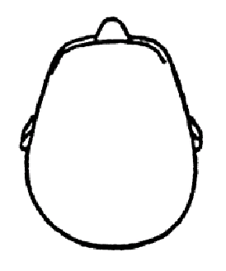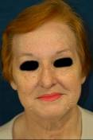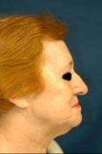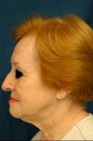

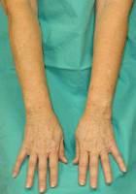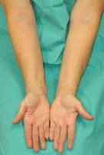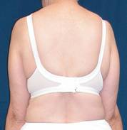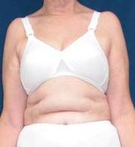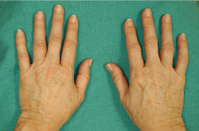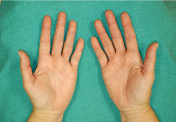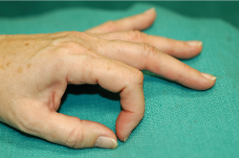
Arm
Arms
Hands/ Fingernails

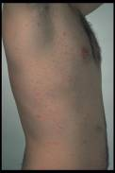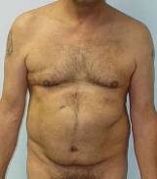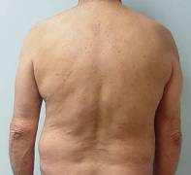
Trunk

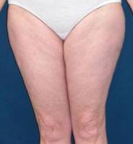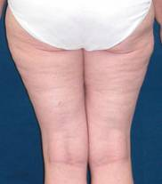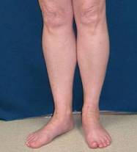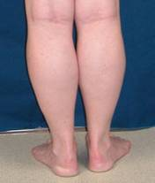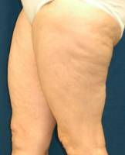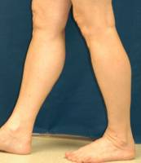
Legs

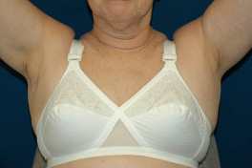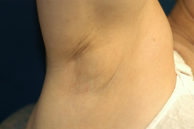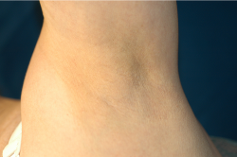
Axilla

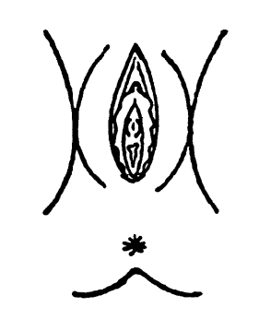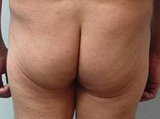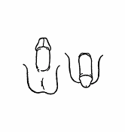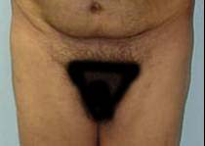
Genitals/ Buttocks

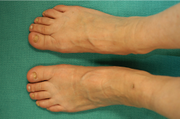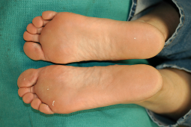
Feet/ Toenails

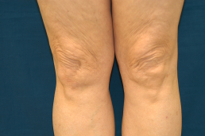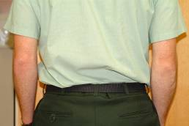
Elbows/ Knees

COMPLEMENTARY VIEWS

If condition involves certain locations, then check to see if any complementary views need to be looked at or photographed.

If Involved: Include Look / Ask / ? Include

Hands Feet Elbows/Knees

Feet Hands Groin

Elbows Knees Scalp

Knees Elbows Scalp

Scalp Face Knees, Elbows

Popliteal fossa Antecubital fossa Neck, Face, hands

Antecubital fossa Popliteal fossa Neck, Face, hands

Nail (any) All nails Oral Mucosa

Groin Buttocks Hands & Feet

Face (Eyebrows) Scalp

Oral Mucosa Genitals

References:
Krupinski E et al. American Telemedicine Association’s practice guidelines for teledermatology. Telemedicine and e-Health 2008 (April): 14: 289-302.

Pak HS, Lappan CM. Basic guide to dermatologic photography. Unpublished document, 2005. Available at: www.americantelemed.org/files/public/membergroups/teledermatology/telederm_DermatologicPhotography.pdf

